San Jose Church of Christ is looking for a Youth Minister!

Church Profile:
San Jose Church of Christ is a church in Jacksonville, FL of about 350 members with a history of long-tenured ministers and positive relationships among staff, elders, and the congregation. We are united around a central vision of disciple-making, which allows us to lead with confidence and purpose rather than being pulled in competing directions. Our ministers are trusted by our elders and supported as subject matter experts, given both the freedom and encouragement to lead their ministry areas well.

Attributes of an Ideal Candidate:
- Compelled by a calling from God to serve in this role
- Biblically grounded teacher and role model
- Adept and flexible in relationship building with teens and families from various backgrounds
- Infuses fun and joy with spiritual intentions
- Works well with the church’s ministry team, especially Children’s Minister, and volunteers
- Demonstrates maturity, good judgment, and wisdom in teaching, counseling, and ministry events

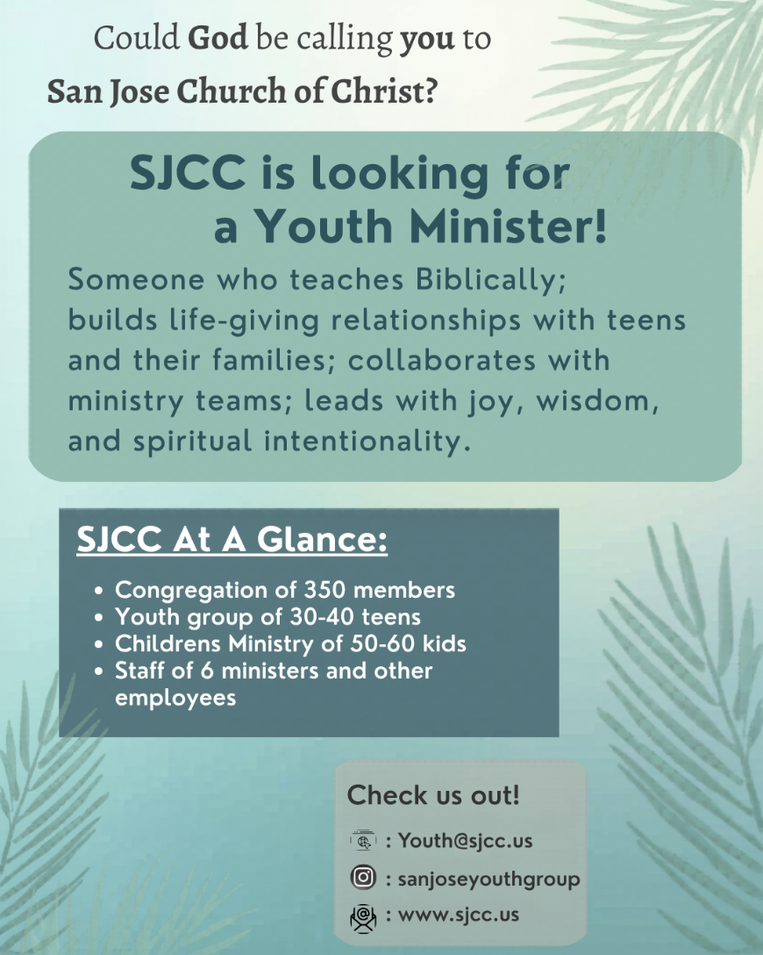

For more information, including instructions to apply, contact: youth@sjcc.us

